Output:

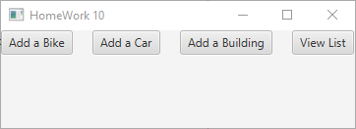



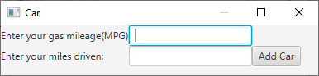

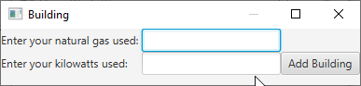

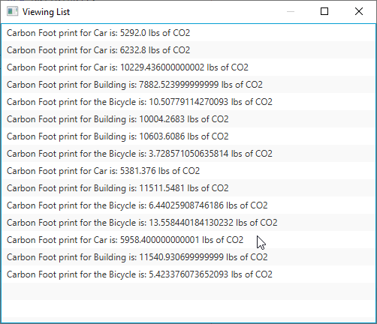

1. Did you successfully get your assignment done? Did it run? Any error? Did you get the correct result? Did you test your program thoroughly?

Yes I successfully completed the homework assignment without any errors in the ending product, I believe the result I got is correct, and I did test it thoroughly.

2. How much time did you spend to complete your assignment?

Longer than it should’ve taken me probably about 3-4 hours.

3. Did you find the assignment easy or challenging for you?

It was easy just lots of testing and messing around with the gui stuff and a few odd issues.

4. Did you write the program yourself? Did you get any help from anyone?

I did write the program myself, the only help I had was the tutorials on blackboard.

5. When you encountered obstacles to complete your program, how did you resolve the issues? Did you use Google to get help? Describe how Google was abled or not able to assist you?

To be honest I only had one major problem throughout the program that took me like over an hour to fix. When you do the setOnAction(e->) stuff for buttons it won’t let you assign result of a TextField to a variable unless that variable is declared as static and that took me a while to find the solution for. I did find it in those tutorials from blackboard though.

6. What did you learn from doing this assignment?

A lot about GUI in java.

7. Any other information you would like to share with your instructor? Make sure you provide program output on each option.

None that i can think of.